NAME:Tanu Singh
SUPERSET ID:6362191
- ReactJS-handson
App.js
import React from 'react';
function App() {
return (
<div>
<h1>Welcome to the first session of React</h1>
</div>
);
}
export default App;
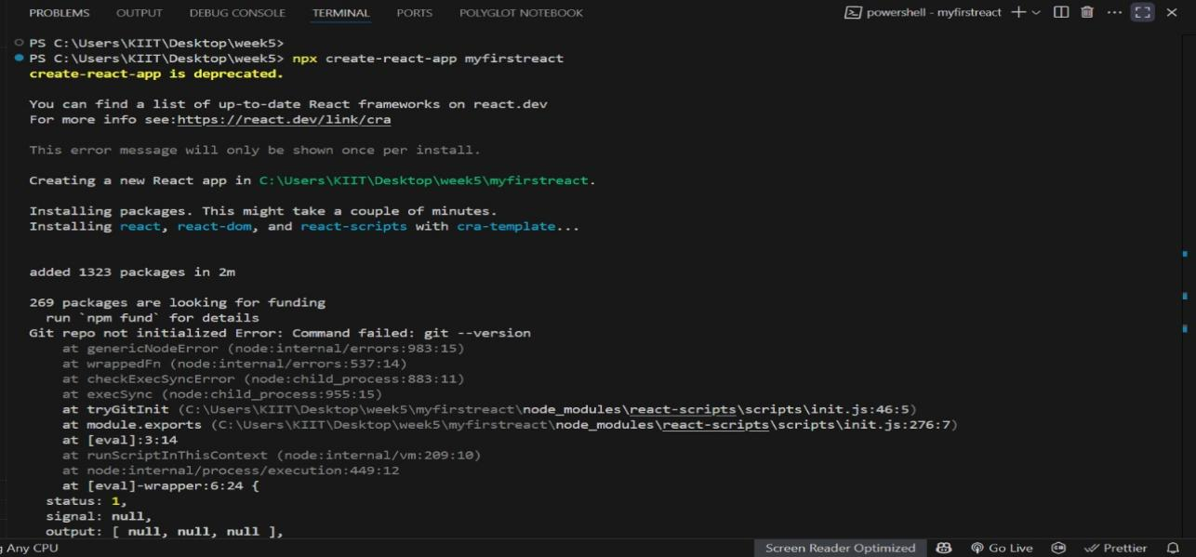

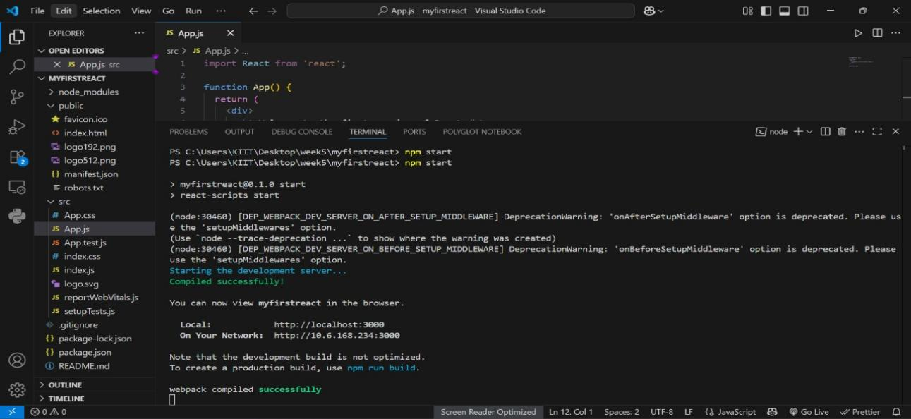

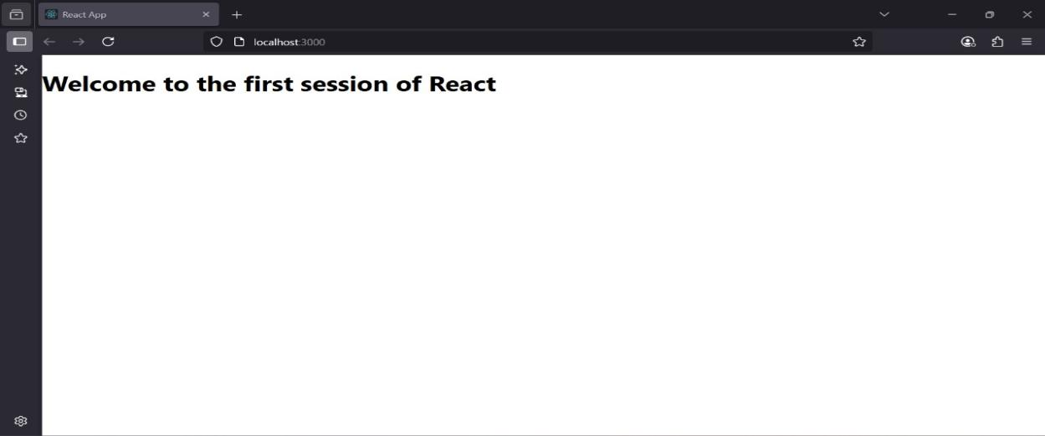

2.ReactJS-Handson

About.js
import React from 'react';
const About = () => {
return (
<div>
<h2>Welcome to the About page of the Student Management Portal</h2>
</div>
);
};
export default About;

Contact.js
import React from 'react';
const Contact = () => {
return (
<div>
<h2>Welcome to the Contact page of the Student Management Portal</h2>
</div>
);
};
export default Contact;
Home.js
import React from 'react';
const Home = () => {
return (
<div>
<h2>Welcome to the Home page of Student Management Portal</h2>
</div>
);
};

export default Home;

App.js
import React from 'react';
import Home from './Components/Home';
import About from './Components/About';
import Contact from './Components/Contact';

function App() {
return (
<div className="App">
<Home />
<About />
<Contact />
</div>
);
}

export default App;

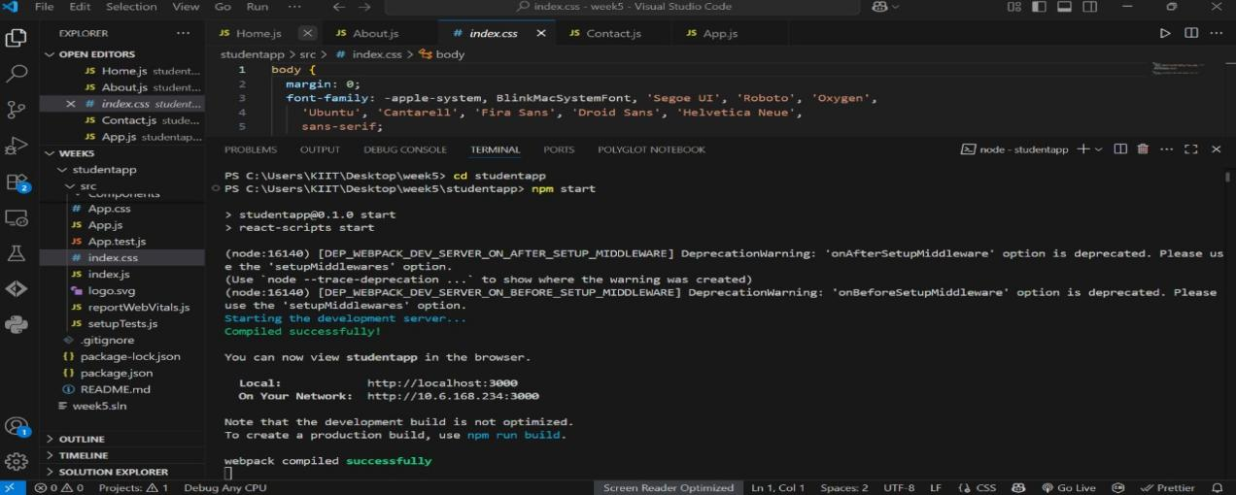

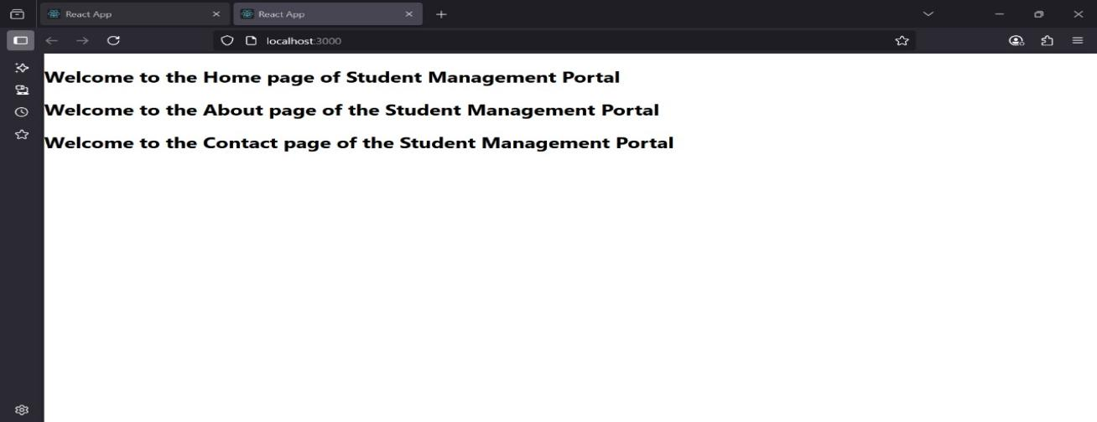

3.ReactJs-Handson

CalculateScore.js
import '../Stylesheets/mystyle.css';
const percentToDecimal = (decimal) => {
return decimal.toFixed(2) + '%';
};
const calcScore = (total, goal) => {
return percentToDecimal(total / goal);
};
const CalculateScore = ({ Name, School, total, goal }) => (
<div className="formatstyle">
<h1><font color="Brown">Student Details:</font></h1>
<div className="Name">
<b><span> Name: </span></b>
<span>{Name}</span>
</div>

<div className="School">
<b><span> School: </span></b>
<span>{School}</span>
</div>

<div className="Total">
<b><span>Total:</span></b>
<span>{total}</span>
<span> Marks</span>
</div>

<div className="Score">
<b>Score:</b>
<span>{calcScore(total, goal)}</span>
</div>
</div>
);

export default CalculateScore;

Mystyle.css
.Name {
font-weight: 300;
color: blue;
}
.School {
color: crimson;
}

.Total {
color: darkmagenta;
}

.formatstyle {
text-align: center;
font-size: large;
margin-top: 40px;
}

.Score {
color: forestgreen;
}
App.js

import React from 'react';
import CalculateScore from './Components/CalculateScore';

function App() {
return (
<div>
<CalculateScore
Name="Steeve"
School="DNV Public School"
total={284}
goal={300}
/>
</div>
);
}

export default App;
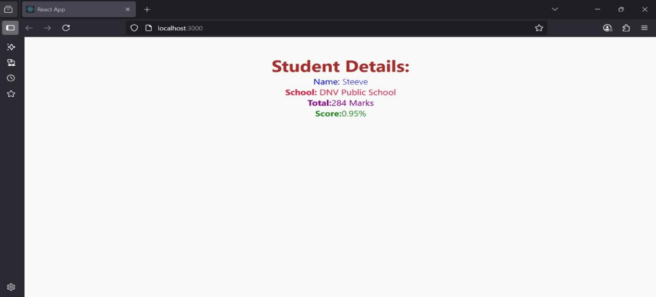

4.ReactJS-Handson
App.js
import React from 'react';
import Posts from './Posts';

function App() {
return (
<div className="App">
<Posts />
</div>
);
}

export default App;
Post.js
import React from 'react';

function Post(props) {
return (
<div>
<h2>{props.title}</h2>
<p>{props.body}</p>
</div>
);
}

export default Post;
Posts.js
import React from 'react';
import Post from './Post';

class Posts extends React.Component {
constructor(props) {
super(props);
this.state = {
posts: []
};
}

componentDidMount() {
this.loadPosts();
}

loadPosts() {
fetch("https://jsonplaceholder.typicode.com/posts")
.then(response => response.json())
.then(data => {
const postObjects = data.map(p => ({
id: p.id,
title: p.title,
body: p.body
}));
this.setState({ posts: postObjects });
});
}

render() {
return (
<div>
<h1>All Posts</h1>
{this.state.posts.map(p => (
<Post key={p.id} title={p.title} body={p.body} />
))}
</div>
);
}
}

export default Posts;
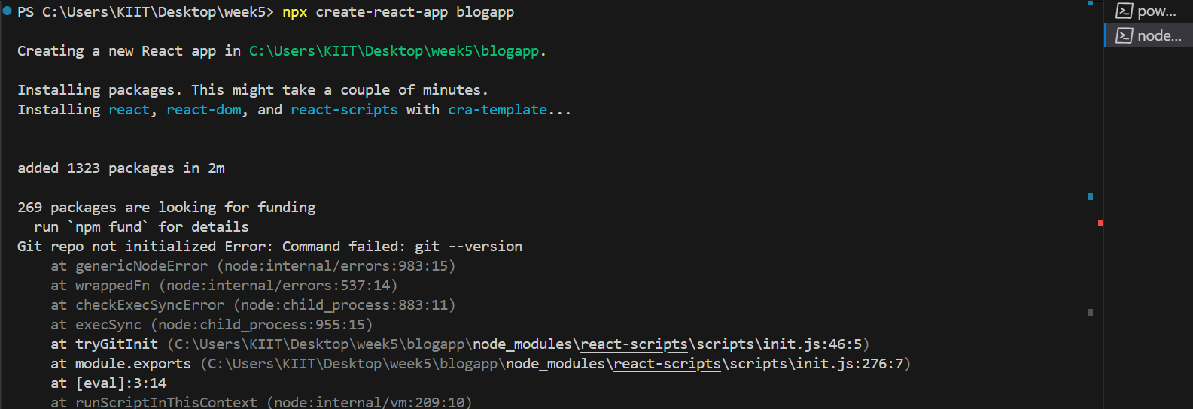
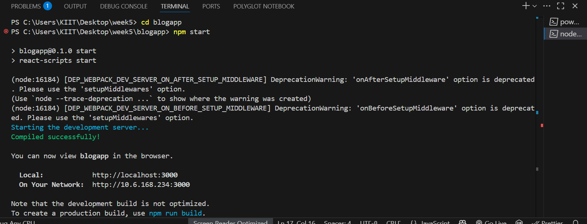

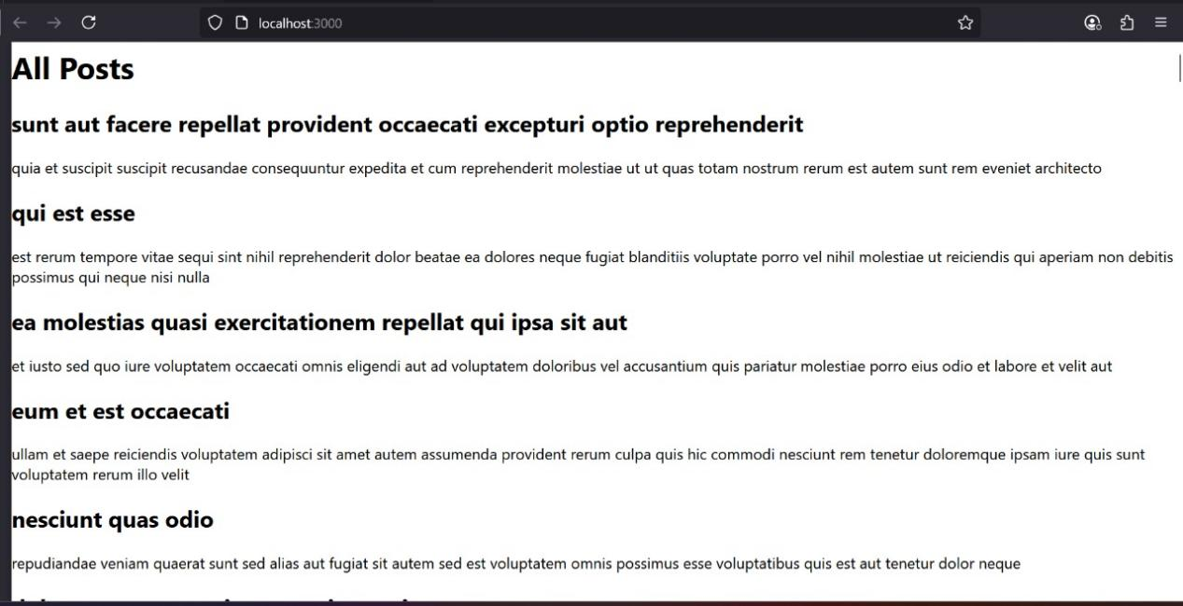

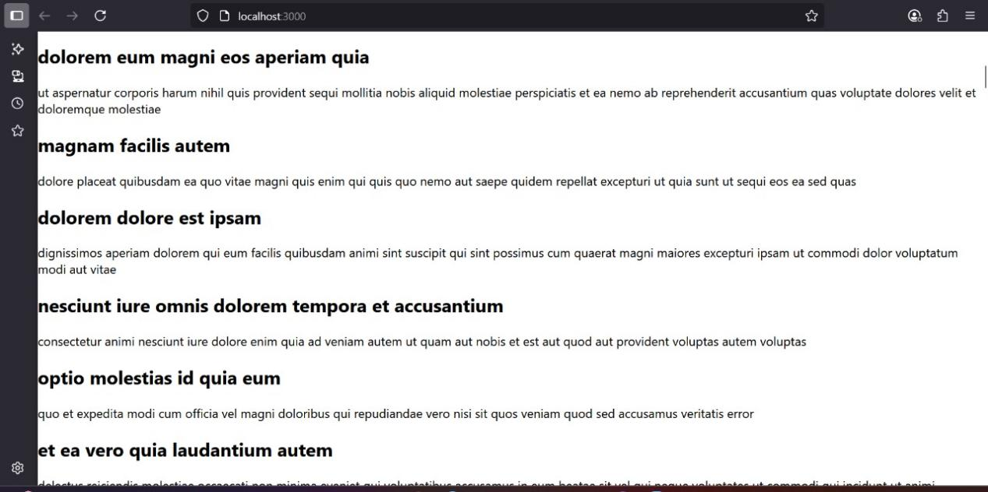

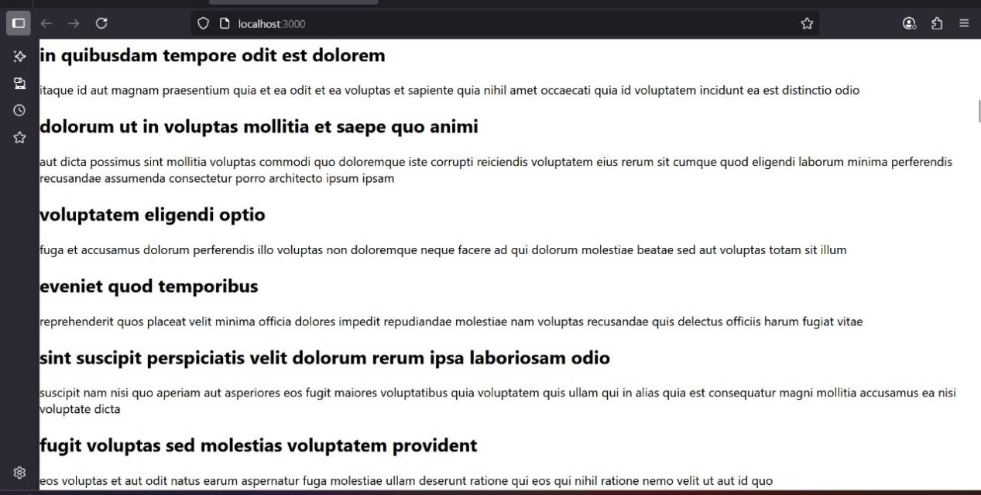



- ReactJS-HOL
Cohort.module.css
.box {
width: 300px;
display: inline-block;
margin: 10px;
padding: 10px 20px;
border: 1px solid black;
border-radius: 10px;
vertical-align: top;
}

dt {
font-weight: 500;
}
CohortDetails.jsx
import React from 'react';
import styles from './CohortDetails.module.css';

const CohortDetails = ({ cohort }) => {
const titleColor = cohort.status.toLowerCase() === 'ongoing' ? 'green' : 'blue';

return (
<div className={styles.box}>
<h3 style={{ color: titleColor }}>{cohort.name}</h3>
<dl>
<dt>Started On</dt>
<dd>{cohort.startDate}</dd>

<dt>Current Status</dt>
<dd>{cohort.status}</dd>

<dt>Coach</dt>
<dd>{cohort.coach}</dd>

<dt>Trainer</dt>
<dd>{cohort.trainer}</dd>
</dl>
</div>
);
};

export default CohortDetails;

CohortDashboard.jsx
import React from 'react';
import CohortDetails from './CohortDetails';
const cohortList = [
{
name: 'INTADMDF10 - .NET FSD',
startDate: '22-Feb-2022',
status: 'Scheduled',
coach: 'Aathma',
trainer: 'Jojo Jose'
},
{
name: 'ADM21JF014 - Java FSD',
startDate: '10-Sep-2021',
status: 'Ongoing',
coach: 'Apoorv',
trainer: 'Elisa Smith'
},
{
name: 'CDBJF21025 - Java FSD',
startDate: '24-Dec-2021',
status: 'Ongoing',
coach: 'Aathma',
trainer: 'John Doe'
}
];

const CohortsDashboard = () => {
return (
<div>
<h2>Cohorts Details</h2>
<div style={{ display: 'flex', flexWrap: 'wrap', gap: '10px' }}>
{cohortList.map((cohort, index) => (
<CohortDetails key={index} cohort={cohort} />
))}
</div>
</div>
);
};

export default CohortsDashboard;
App.js
import React from 'react';
import CohortsDashboard from './CohortsDashboard';

function App() {
return (
<div className="App">
<CohortsDashboard />
</div>
);
}

export default App;